Logic Design Styles

D. Mukhopadhyay
Dept. of Electronics and Telecommunication Engg
Jadavpur University, Kolkata – 700 032
dmukho@yahoo.com

The value of any logic function is either a “0” or a “1”. We can say that in a digital (logic) design, the output should be either 0 or 1. The design of a digital circuit, therefore, necessarily means connecting the output node to either the power supply (logic 1) or to ground (logic 0).

There is a capacitance associated with the output node. This capacitance is an appropriate combination of the output capacitance of the previous stage, input capacitance of the next stage (device capacitance) and any other stray capacitance due to connection wires etc (wiring capacitance). In logic state 0 this capacitance has to remain uncharged. In the logic state when the output is at logic 1, this capacitance needs to be charged to V_{DD}. The speed of operation of the circuit is determined by the speed with which this output capacitance gets charged or discharged through the available current path. Value of this capacitance and the resistance of the charging and discharging path control the speed of the circuit.

So a digital logic circuit design involves creating a network that will connect the output node to the power supply (the pull-up network, PUN) and another disjoint network that will connect the output node to the ground (the pull-down network, PDN). We can use several techniques to achieve this. This gives rise to several logic design styles. Each style has its own advantages and disadvantages and the designer has to make a choice of the appropriate style and then optimize the circuit keeping in mind the demands on the resources (speed, power, area, and design time) for specific applications.

1. Complementary Design Style (CMOS Logic Style)
In this design style, the output node is connected to the power supply (logic 1) through the PUN or is connected to ground (logic 0) through the PDN. In complementary logic style, the input vectors (input logic variables, primary inputs) are connected to the inputs of the PUN and the PDN such that when one is “ON” (short-circuited), the other is “OFF” (open-circuited) and vice-versa. This gives rise to functional complementariness of the circuit. At no pint of time are both these networks simultaneously “ON”, except during the short time interval during which the input variables change their logical states. There is thus no direct connection between the supply and ground except during a short time that is determined by the slope of the input voltage waveforms. The power requirement of these circuits is thus very small and this design style is extremely suitable for designing low-power circuits.

We use the PUN to pass logic 1 to the output and the PDN to pass logic 0 to the output. We know that an n-channel transistor does not pass logic 1 nicely, the output remains at (V_{DD} − V_{T}). There is thus logic degradation if we try to pass logic 1 through an n-channel transistor. By complementary logic, a p-channel transistor does not pass logic 0 nicely, the output remains at (0 + |V_{T}|). There is logic degradation if we try to pass logic 0 through a p-channel transistor. By inverse argument we note that an n-channel transistors pass logic 0 nicely (without degradation) while p-channel transistors pass logic 1 without degradation.

The rule of the game is now clear. Use only p-channel transistors to construct the PUN and use only n-channel transistors to construct the PDN.

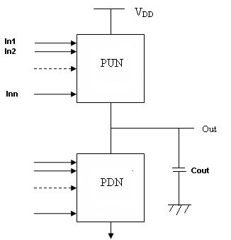
Fig 1 CMOS logic style

A second type of complementation: structural, has now become an attribute to the circuit. The circuit thus has two types of complementation: (1) functional and (2) structural. Functional complementation ensures that the PUN and PDN has behavioural complementation: when one is ON the other is OFF and vice-versa. Structural complementation is due to the fact that two different types of transistors are involved in the construction of the circuit, p-channel transistors only for the PUN and n-channel transistors only for the PDN.

Rules for designing logic circuits to implement a given logic function
The specifications and functionality of a digital system is mostly given in a natural language. We then perform system level design using behavioral models and algorithms to reach the stage where the system is broken into a number of connected sub-systems. Logic design is then performed on each subsystem. The result of this procedure is either a logic equation or a truth table. We then perform the circuit level design using any of the logic design styles.

Theoretically, it is always possible to express the behavior of any digital subsystem by a logic equation. The circuit level design that we describe here starts after we get the logic equation or the truth table. We can always get a logic equation from a given truth table.

It is to be noted that CMOS logic design style can design the circuit only if the logic equation is expressed in a complementary form. Stated simply, it means that the logic equation with which we should start our CMOS logic design must have a bar over its right hand side expression. If the bar is not there, we can perform some manipulations using Boolean algebra to get an expression with a bar over it. If that is not easy, we ourselves put a bar over the expression. We then do the design and invert the output by using an inverter.

The steps of the design are:
- Transform the logic equation so that the expression in the right hand side has a bar over it.
- Having the bar over the rhs, forget the bar and design the PDN first. Connect each primary input to the gate of an n-channel transistor. If inverted inputs are needed, invert the primary inputs through an inverter.
- Whenever there is an AND operation in the logic expression, connect the transistors in series and whenever there is an OR operation, connect the transistors in parallel. Complete the design of the PDN.
- Having designed the PDN, PUN need not be designed separately. The PUN will be the dual of the PDN (functional complementation). We have to design the dual network by using the Euler graph. In simple cases, the procedure is simple. Whatever is in series in the PDN, connect them in parallel in the PUN, and whatever is in parallel in the PDN, connect them in series in the PUN. This completes the design of the PUN. The output is taken from the common point between the PUN and the PDN.
- If there is no bar over the expression in the rhs or if the bar can not be devised by simple algebraic manipulations, do the design by putting a bar over the expression and then invert the output using an inverter.

Advantages and disadvantages of the CMOS logic design style
Advantages:
- The design steps are very simple. The design time is very small.
- The circuit consumes very little power (why?). The design style is extremely suitable for low-power design.
Disadvantages:
- The transistor count is very high. We need at least 2N number of transistors for an N-variable expression. Unsuitable for large fan-in circuits.
- The high transistor count needs more silicon area.

The simplest of the logic circuit to be designed by CMOS logic style is the inverter. The circuit behavior should manifest the logic equation F = A/. Since there is only one logic input, A, the PUN as well as the PDN consist of only one transistor, p-type for PUN and n-type for PDN. The circuit is as shown in Fig. 2.

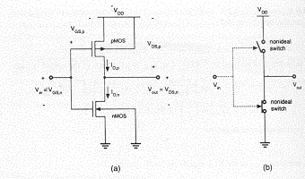
Fig. 2 (a) CMOS inverter (b) Equivalent switch representation
Exercise
- Implement the following logic functions in CMOS logic design style.
(i) F = (AB)/ (ii) F = (A+B)/ (iii) F = AB/ + A/B (iv) F = SA + S/B
(v) F = A(B + C) (vi) F = AB + CD (vii) A full adder
- Pseudo n-MOS Design Style
We have noted that a CMOS logic circuit with a fan-in of N needs at least 2N number of transistor, because of the complementary function performed by the PUN. We now note that the PUN, in a way, serves the purpose of a load to the PDN. So we propose to have the PDN to perform the logic function and replace the PUN by a single transistor that acts as a load resistor. Obviously a p-channel transistor is chosen as this load transistor, because the lower value of hole mobility allows us to realize a given load resistance value in a smaller area for a p-channel transistor. The circuit schematic is shown in Fig. 3.

PDN
Out
V_{DD}
Fig 3 Pseudo n-MOS logic circuit

It is to be noted that for the p-type transistor to act as a load resistor, it should always remain in the conducting mode. We assure this by connecting the gate of the p-channel transistor to ground (the lowest potential available in the circuit). This ensures that the p-channel transistor is always in saturation and conducts current. This design style has been termed the pseudo n-MOS design style, because of historic reason. In the eighties when p-channel transistors were difficult to fabricate due to technological limitation (what could this limitation be?), n-channel transistors were used as the load device. When p-channel transistors replaced the load n-channel transistors, the name stuck with a “pseudo” prefix. Also the circuit consists of n-channel transistors only, except one p-channel load device. Hence the name n-channel continued but with the qualifier “pseudo” indicating ‘almost”.

The advantage that we get in this circuit is that the transistor count gets reduced from 2N to N+1. For large fan-in this is a considerably lesser area penalty. Also there is no logic degradation (P-channel is used to pass logic 1 and n-channel is used to pass logic 0.

The disadvantage that we get in this circuit is that there is always some current flow through the p-channel load transistor, it is always ON. This design style is, therefore, not suitable for low-power design.

- Transmission Gate (TG) Logic Style
We know an n-channel transistor does not pass a logic 1 nicely, there occurs a logic loss to the extent of the threshold voltage. Also a logic 0 cannot be nicely passed through a p-channel transistor. Hence to pass an input data (which can be either a 0 or a 1, depending on the application program) an n-channel transistor in parallel with a p-channel transistor is used. This is the transmission gate. We also note that evaluating a logic function, in the final analysis is transfer of logic data from one point of the circuit to another point. Transmission gates are used to appropriately transfer this data and this design style has come to be known as the “Transmission Gate (TG) Logic Design Style”.

When the input data is logic 1, both the transistors pass the voltage up to V_{DD} − V_{T}. The remaining part up to V_{DD} is passed by the p-channel transistor. Similarly when the input data is logic 0, both the transistors pass the voltage up to V_{T}. The remaining part up to 0 is passed by the n-channel transistor. Since two parallel paths are available to the data during most of the transmission, the effective resistance gets lowered and the switching speed is higher. This is the greatest advantage of the TG logic style. Also it is often found that the transistor count is less than that in CMOS logic style and can be reduced by intelligent design.

Exercise:
Design the XOR gate by TG logic, such that the circuit needs (i) 8 transistors, (ii) 6 transistors.

- Dynamic Logic Design Style
In the dynamic design style, we use only the PDN to evaluate the logic. We pre-charge all the output nodes to logic 1 by using a clock. When the clock is 0, the output nodes are charged to 1 (nφ circuits), when the clock is 1 the logic is evaluated by the PDN. It is to be noted that this evaluation is complementary, the output becomes 0 when the logic is true (Fig 1). We may also have pφ circuits where all the output nodes are pre-charged to logic 0 and discharged (?) to logic 1 when the logic is true. And then extending the idea of complementary CMOS design, we can also have np- φ circuits.
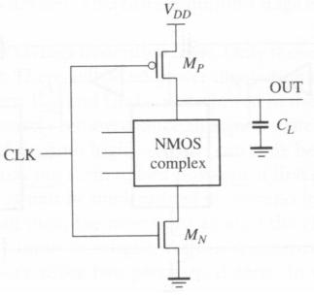
Fig 1 Dynamic logic gate

A complication arises when one dynamic gate feeds another (Fig 2). Since all the output nodes are pre-charged high, all inputs to subsequent gates are high, implying that there will be an active path to ground from each output node as soon as the foot transistor is turned ON. Once an output node has been discharged, it cannot go high until the next pre-charge phase. Therefore, a direct connection is not possible.
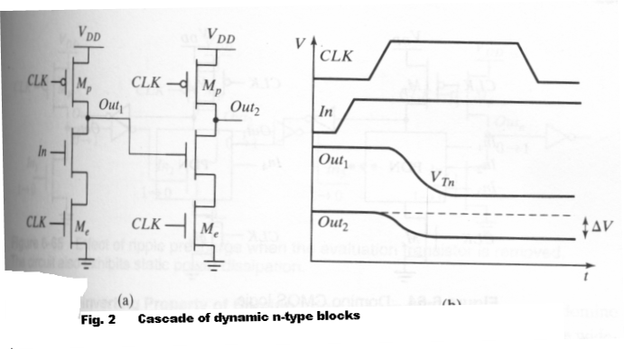

5. Domino Logic Design Style
A simple solution exists for this problem: add a static inverter to the output of all dynamic gates. Then define a “stage” as the original dynamic gate plus the inverter. The output of each stage is now low during pre-charge. Therefore all n-MOS transistors are off during pre-charge and can only be turned on during the evaluate phase. The combination of a dynamic stage and a static inverter is referred to as a “domino stage”, and circuits using this form of dynamic logic are referred to as “domino logic” circuits (Fig. 3).

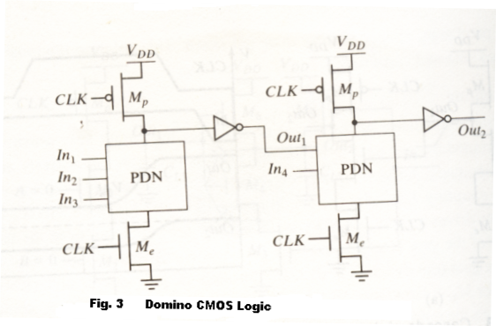
Exercise:
1. Use dynamic logic style to design (i) an inverter, (ii) F = (A+B)C+D (iii) A NAND gate
2. What is the problem when we try to cascade dynamic logic circuits?
3. Write an essay on the evolution of logic gates bringing out the essential features of each design style.

